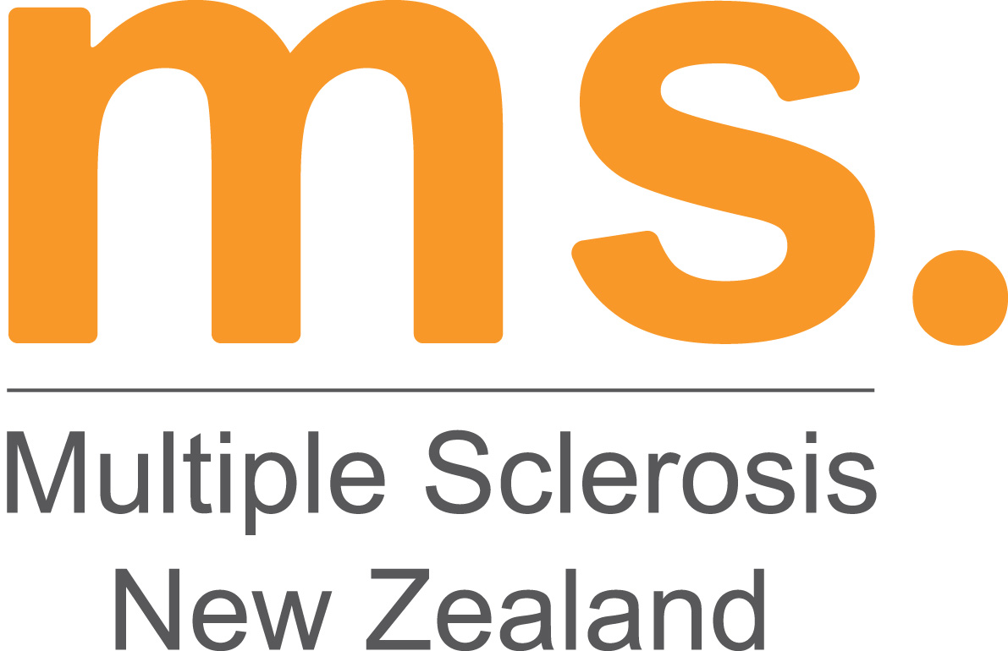

Multiple Sclerosis Society of New Zealand Inc.

Mastering Mountains Grant
APPLICATION FORM FOR 2017/8

Information and Help

- Please attach any further information that you believe may be relevant to your application.
- If you need assistance in filling out your form please contact your Regional MS Society representative or the MS Society of NZ on 0800 MS LINE (67 5463)

Personal Details

Last Name:
First Name(s):
Home Address:
Home Phone:
Work Phone:
Mobile:
Email:

Request Details

Intended adventure:
Provider:
Amount Requested: $
Give a brief outline of who you are, why you chose this adventure, how will this benefit you, why you need a grant to help achieve this:

State why you think you deserve this grant:

Please outline the steps you have taken and will take (e.g. a training plan or schedule) in preparation for this adventure:

Is there any other information you would like the panel to know?:

Referees

Please include the names and contact details of two people who are willing to be contacted in support of your application:

1. Full Name:
Home Address:
Daytime phone:
Email:
2. Full Name:
Home Address:
Daytime phone:
Email:

Authentication from Regional MS Society

- Please have your Field Worker or Regional MS Society representative fill in the information below as confirmation of your identity and diagnosis of MS.

Regional MS Society Representative Full Name:
Regional MS Society/Region:
Signature:………………………………………………………………………. Date: / /

Authentication from Doctor

- All applicants must have authentication from their Primary Health Professional that they are able to partake in the activity applied for.
- If you are not a member of the Regional MS Society, please have your local GP complete the details instead.

GP Full Name:
Practice Name and Location:
Signature:………………………………………………………………………. Date: / /

Declaration

- I confirm that the information contained in this application is true and correct.
- I am aware and accept that the personal information collected about me in connection with this application will be used by the Selection Panel for the purposes of assessing this application only.
- I confirm that I have a diagnosis of Multiple Sclerosis.
- If I am successful in my application I give permission for my photo and information relating to the application (i.e. your adventure activity) to be used for publicity purposes, including, but not limited to, contributions to MSNZs communications, Annual report and the blog at MasteringMountains.org.
- I agree that I will seek and provide written confirmation from my Primary Health Care Provider (e.g. GP or Neurologist) that the adventure I have chosen is safe for me to undertake, understanding my health status.
- I confirm that the activity provider is registered, has public liability insurance and is aware of my health condition. I will provide on request written confirmation from the activity provider that they are aware of my condition and the requirements associated.
- I take full responsibility for my health and safety. While I am receiving a grant from MSNZ and Mastering Mountains there is no liability placed on MSNZ or Mastering Mountains should an accident occur.
- I will adhere to all the rules and health and safety policies of the activity provider ensuring that I have read or have had them read to me, and that I have understood the terms and conditions.
- I have attached a breakdown of costs relating to my chosen challenge and indicated where I would like support from the Mastering Mountains Grant
- I agree to fundraise and donate a minimum of 50% of the funds raised beyond the costs of my challenge to Mastering Mountains, to help future grant applicants.
Signature:
Date / /

Post your completed application to reach:
Mastering Mountains Selection Panel
MS Society of NZ
PO Box 32124
Christchurch 8147

by 31st October 2017

Multiple Sclerosis New Zealand
PO Box 32124, Christchurch 8147
0800 MS LINE (67 54 63) info@msnz.org.nz www.msnz.org.nz

