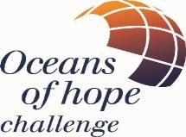
OCEANS OF HOPE CHALLENGE
NEW ZEALAND
OVERCOMING CHALLENGES TOGETHER

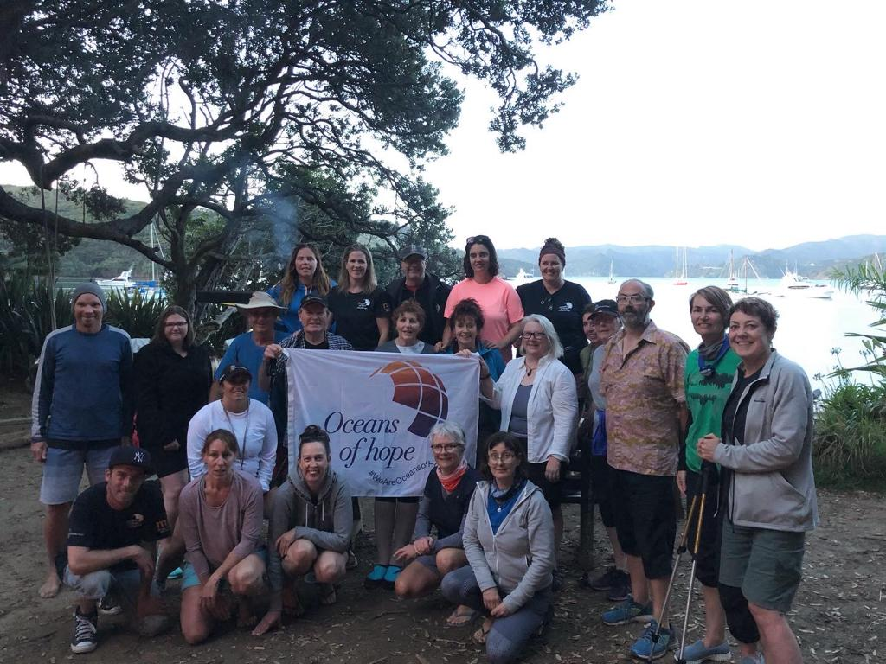

Come and join us for a life changing sailing adventure in 2022
Dates: 28th November to 2nd December
Our aim is to help you gain self-confidence and a renewed sense of empowerment. The camaraderie of
sailing a boat with people who have similar experiences creates an environment where people can comfortably share their hopes and fears. The Oceans of Hope experience is a catalyst for creating
lasting friendships and a sense of community.

Whether you have sailed before or not, this is an opportunity not to be missed! https://m.youtube.com/watch?v=d2sMqPeEEA8&feature=emb_logo

We may sail into Kawau Island, Great Barrier Island, Smokehouse Bay, the poor Knights Islands, Whangamumu,
Great Barrier Island and more.
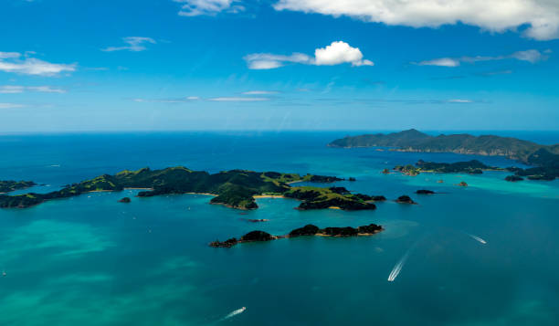

Due to Covid-19 this challenge is open to people living in New Zealand only until border restrictions change.

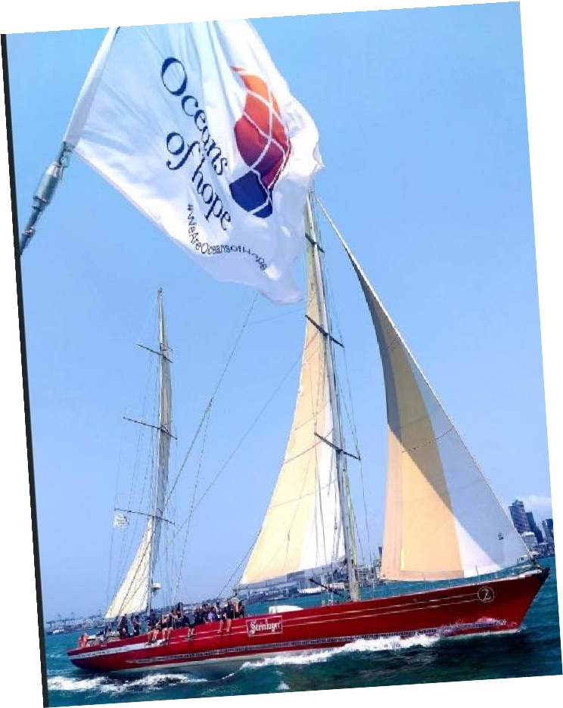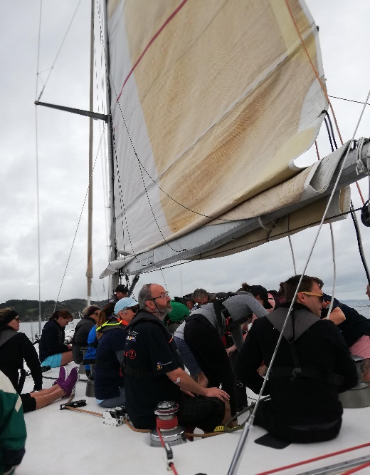

Steinlager 2 is fully equipped to make your stay on board as comfortable and safe as possible. There will be a skipper and crew to help you learn and ensure you get everything you want from this experience. You can learn to sail, improve your sailing skills, swim in the warm water, and enjoy the sun and scenery. If you come alone, you will certainly make a host of new life - long friends.

You will be sharing the communal cabin with fellow crew.
Everyone will get involved in preparing meals aboard the yacht– there is nothing better than enjoying great food and great company on a yacht under the sun or the stars.

Participants should be able to walk a few steps to access the boat and 6 steps (with rail) up and down into the boat interior

Still a little apprehensive? Watch the following to hear from our participants
Achieve Your Goals: https://youtu.be/4sjOD4mjbVA Overcome Limitations: https://youtu.be/3d4T8UJrsgI Power of Community: https://youtu.be/7cN2HpBoq8s

EMBARKING: 0900 Auckland Viaduct Marina
DISEMBARKING: 1600 Opua Wharf, Beechey Street, Opua.
COST: $1454.00 (including food)

FOR AN APPLICATION FORM EMAIL: oceansofhopechallengenz@gmail.com

FOLLOW OUR ADVENTURES:
website www.oceansofhope.co.uk
Facebook Oceans Of Hope Challenge
Instagram: Oceans of Hope Challenge
Twitter https://twitter.com/oohchallenge

Due to Covid-19 this challenge is open to people living in New Zealand only until border restrictions change.

OCEANS OF HOPE UK CHARITY NO. 11080234

