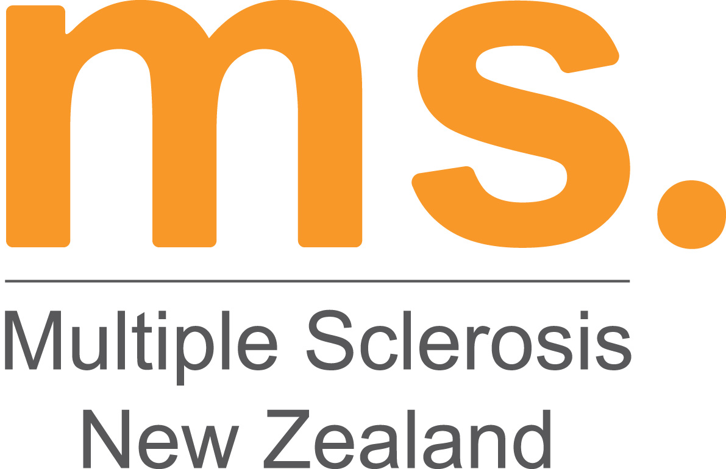

Multiple Sclerosis Society of New Zealand Inc.

Mastering Mountains Grant (NZ based challenges for people with MS or FND)
APPLICATION FORM
Open September – October Annually

Information and Help

- Please attach any further information that you believe may be relevant to your application.
- If you need assistance in filling out your form please contact your Regional MS Society representative or the MS Society of NZ on 0800 MS LINE (67 5463)

Personal Details

Last Name:
First Name(s):
Home Address:
Home Phone:
Work Phone:
Mobile:
Email:

For Office Use only: | Date Received: | Status:

Request Details

Intended adventure:
Provider:
Amount Requested: $

Give a brief outline of who you are, why you chose this adventure, and how will this benefit you:

State why you need a grant to help achieve this:

Please outline the steps you have taken and will take (e.g. a training plan or schedule) in preparation for this adventure:

Is there any other information you would like the panel to know?

Referees

Please include the names and contact details of two people who are willing to be contacted in support of your application:

1. Full Name:
Home Address:
Daytime phone:
Email:
2. Full Name:
Home Address:
Daytime phone:
Email:

Are you a member of a Regional MS Society?

- If so, please have your Field Worker or Regional MS Society representative fill in the information below as confirmation of your identity. Otherwise, please leave blank.

Regional MS Society Representative Full Name:
Regional MS Society/Region:
Signature: ………………………………………………………………………. Date: / /

Authentication from Doctor

- Please have your Primary Health Professional (e.g. your GP, Neurologist, Neurology Nurse, Physiotherapist, Neurophysiologist, or Occupational Therapist) fill in the information below as confirmation of your identity and diagnosis of Multiple Sclerosis or Functional Neurological Disorder.
- All applicants must have authentication from their Primary Health Professional that they are able to partake in the activity applied for.

Primary Health Professional’s Full Name:
Practice Name and Location:
Signature: ………………………………………………………………………. Date: / /

Declaration

- I confirm that the information contained in this application is true and correct.
- I am aware and accept that the personal information collected about me in connection with this application will be used by the Selection Panel for the purposes of assessing this application only.
- I confirm that I have a diagnosis of Multiple Sclerosis or Functional Neurological Disorder.
- If I am successful in my application I give permission for my photo and information relating to the application (i.e. your adventure activity) to be used for publicity purposes, including, but not limited to, contributions to MSNZs communications, Annual report and the blog at MasteringMountains.org.nz.
- I agree that I will seek and provide written confirmation from my Primary Health Care Provider (e.g. GP or Neurologist) that the adventure I have chosen is safe for me to undertake, understanding my health status.
- I confirm that the activity provider is registered, has public liability insurance and is aware of my health condition. I will provide on request written confirmation from the activity provider that they are aware of my condition and the requirements associated.
- I take full responsibility for my health and safety. While I am receiving a grant from MSNZ and Mastering Mountains there is no liability placed on MSNZ or Mastering Mountains should an accident occur.
- I will adhere to all the rules and health and safety policies of the activity provider ensuring that I have read or have had them read to me, and that I have understood the terms and conditions.
- I have attached a breakdown of costs relating to my chosen challenge and indicated where I would like support from the Mastering Mountains Grant.
- I agree to fundraise for Mastering Mountains, to help future grant applicants. Of the funds raised, I agree to donate a minimum of 50% to Mastering Mountains.
Signature:
Date / /

Post your completed application to reach:
Mastering Mountains Selection Panel
MS Society of NZ
PO Box 1192
Christchurch 8140

by 31st May

Multiple Sclerosis New Zealand
PO Box 1192, Christchurch 8140
0800 MS LINE (67 54 63) | info@msnz.org.nz | www.msnz.org.nz

